

Practices for Secure Software Report

Table of Contents
Document Revision History 3
Client 3
Instructions 3
Developer 4
1. Algorithm Cipher 4
2. Certificate Generation 4
3. Deploy Cipher 4
4. Secure Communications 4
5. Secondary Testing 4
6. Functional Testing 4
7. Summary 4
8. Industry Standard Best Practices 4

Document Revision History

Version | Date | Author | Comments
1.0 | 02-17-2026 | Marcus Moore

Client



Developer
Marcus Moore

Algorithm Cipher

Recommended encryption algorithm cipher: AES-256-GCM
Recommended cryptographic hash algorithm: SHA-384

Due to the security vulnerabilities such as risks of data interception and it being widely regarded as an efficient and secure industry approved encryption, I recommend the encryption algorithm cipher AES-256 in Galois/Counter Mode. Advanced Encryption Standard or AES is a symmetric block cipher that was standardized in 2001 by NIST. The AES cipher supports key sizes of 128, 192, and up to 256 bits. AES-256 is the 256-bit key size and has very high brute force resistance. GCM is an authenticated encryption mode that with AES provides confidentiality, integrity, along with high performance. AES-256-GCM is widely used in TLS/HTTPS.

AES itself is not a hash function but includes authentication and uses an internal mechanism GHASH to generate authentication tags. This ciphers bit levels are a key size of 256 bits, block size of 128 bits and authentication tag that typically is 128 bits. The use of random numbers are used for key and IV generation as well as session key derivation. AES is a symmetric key algorithm. This means that the same key is used for encryption and decryption. Symmetric keys are faster and are typically a better choice for encrypting large amounts of data. Non-symmetric keys are usually used for digital signatures and key exchange.

Certificate Generation

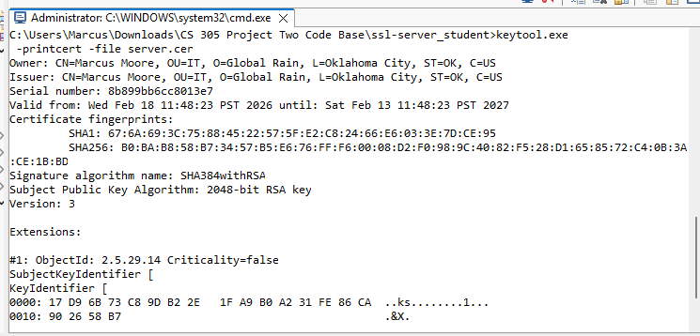

Deploy Cipher

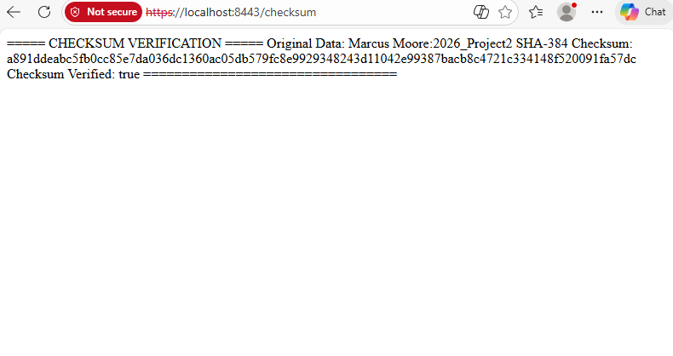

Secure Communications

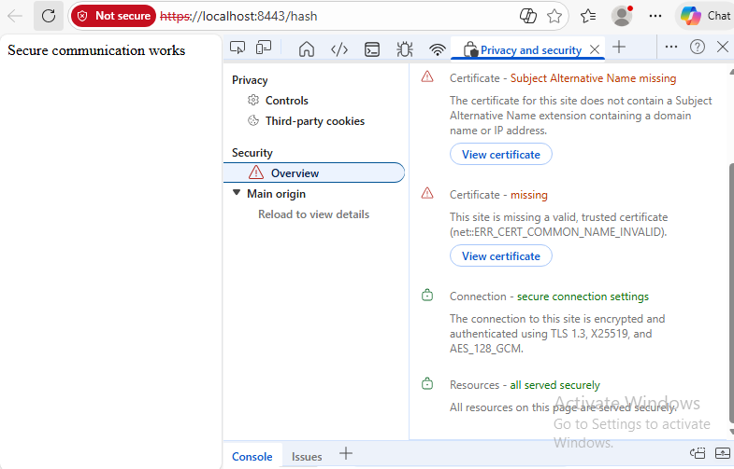

Secondary Testing

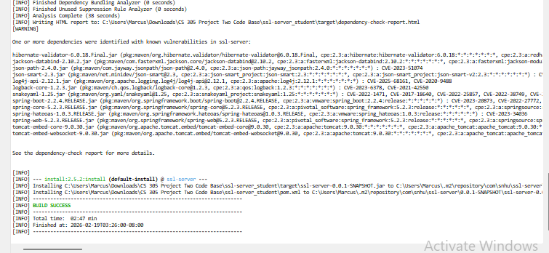

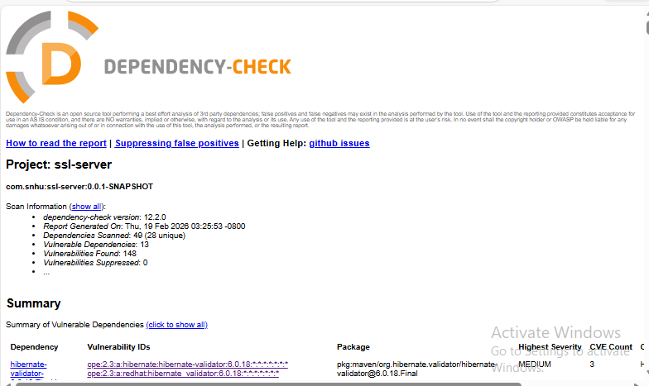

Functional Testing

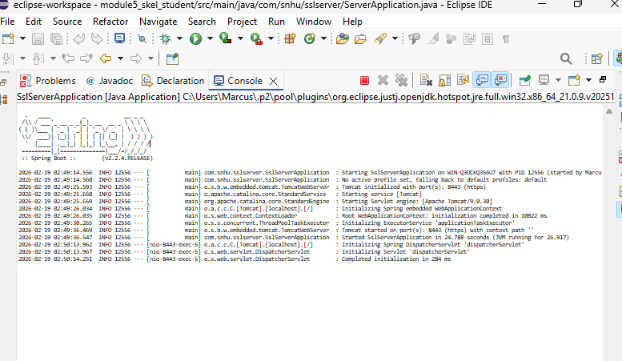

Summary

The code has been refactored in multiple ways to comply with security testing protocols such as adding checksum verification with SHA384 and adding a keystore. I also added a self signed certificate to the code and used TLS/HTTPS assigned to server port 8443. A hash controller method was also added to the code to verify a secure connection. The main area of security that was addressed by refactoring the code is cryptography by adding encryption to the code.

Industry Standard Best Practices

I used industry standard best practices to maintain security by using a strong cryptographic standard and explicit algorithm declaration. There are many benefits of using industry best practices like risk reduction, legal compliance, and maintaining a strong reputation along with customer trust.

